**API Instructions**  
  
  
1- Clone this repository (I’ve created a pull request to nuix branch as well)  
<https://github.com/jgarceso/CodingExercise.git>  
  
You shoul have this folder now:  
  
  
Inside this folder, you can go to NUIX folder that contains the api code.  
  
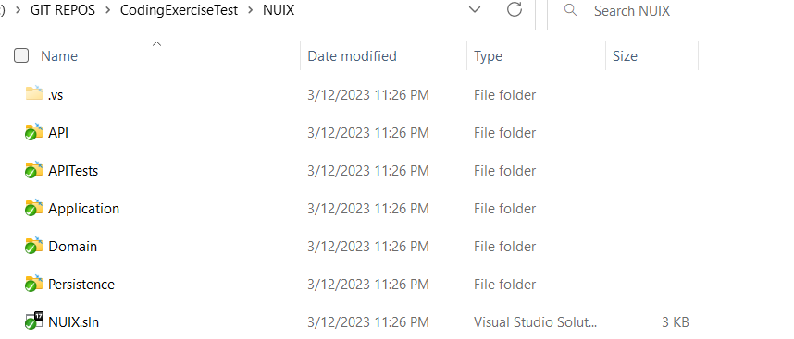

After opening NUIX.sln, you will need to make some changes:  
  
The API is configured to build a SQL SERVER database and initial data with entity framework following the approach code first.  
The Migration files are already part of the solution so you don’t need to generate them.  
  
The change that you need to make (assuming that you have a sqlserver instance running in your local machine) is in the appSettings.Development.json. Update the connection string to your local sqlserver.  
  
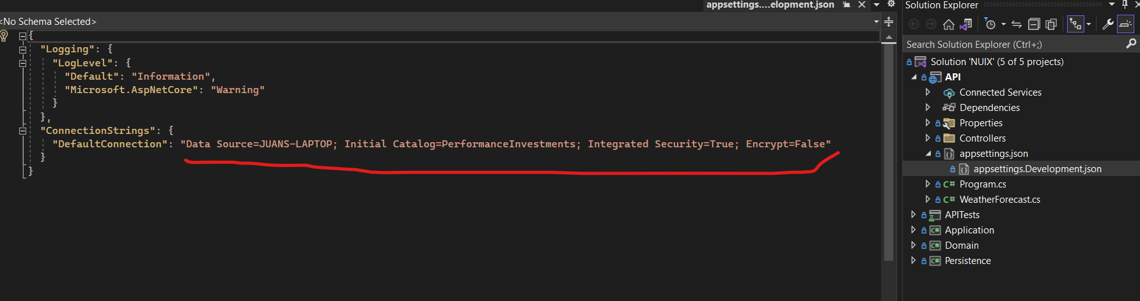

**Running the app.**

After you press in visual studio the debug button 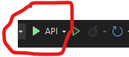, you will have swagger interface in the browser for testing the API. Make sure you set the API as your start up project.  
  
  
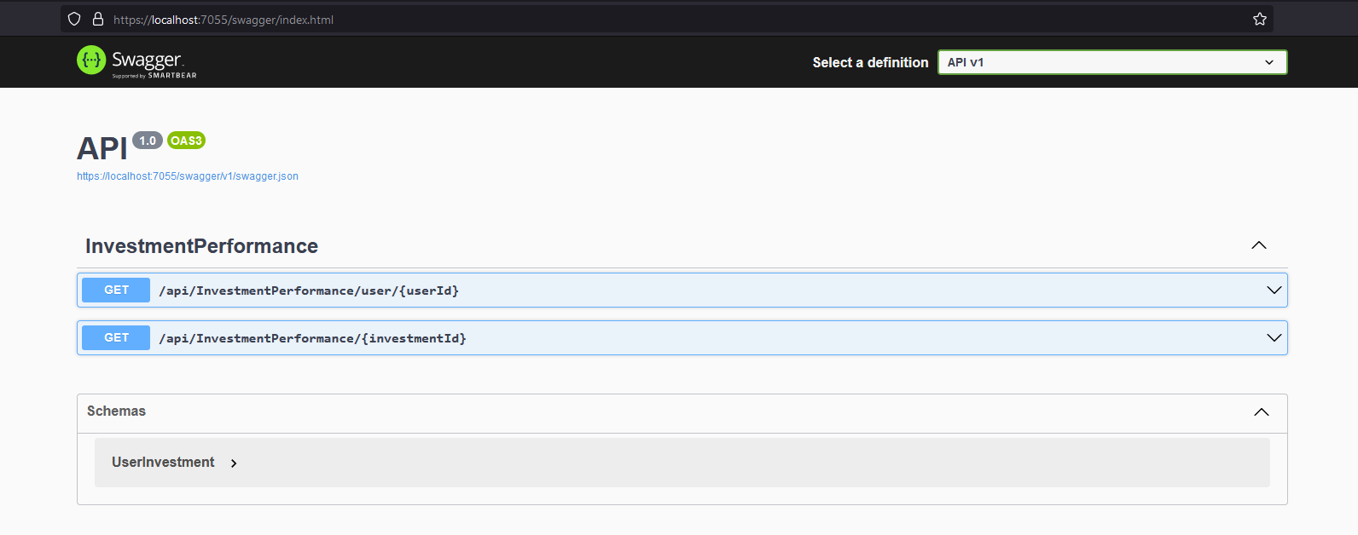

After you run the app, you should have created the following database and tables.

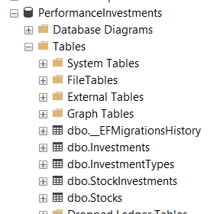

Data was seeded when you ran the app.  
  
Users data is assumed to be in the database, so I didn’t consider that datamodel part. I just assumed that I can have the user Id from where the end point is gonna be used and as an integer.  
  
See the seed data class to check the data prepolutated for testing purposes.

For example userId: 1 and InvestmentId 1 are valid and should return results.

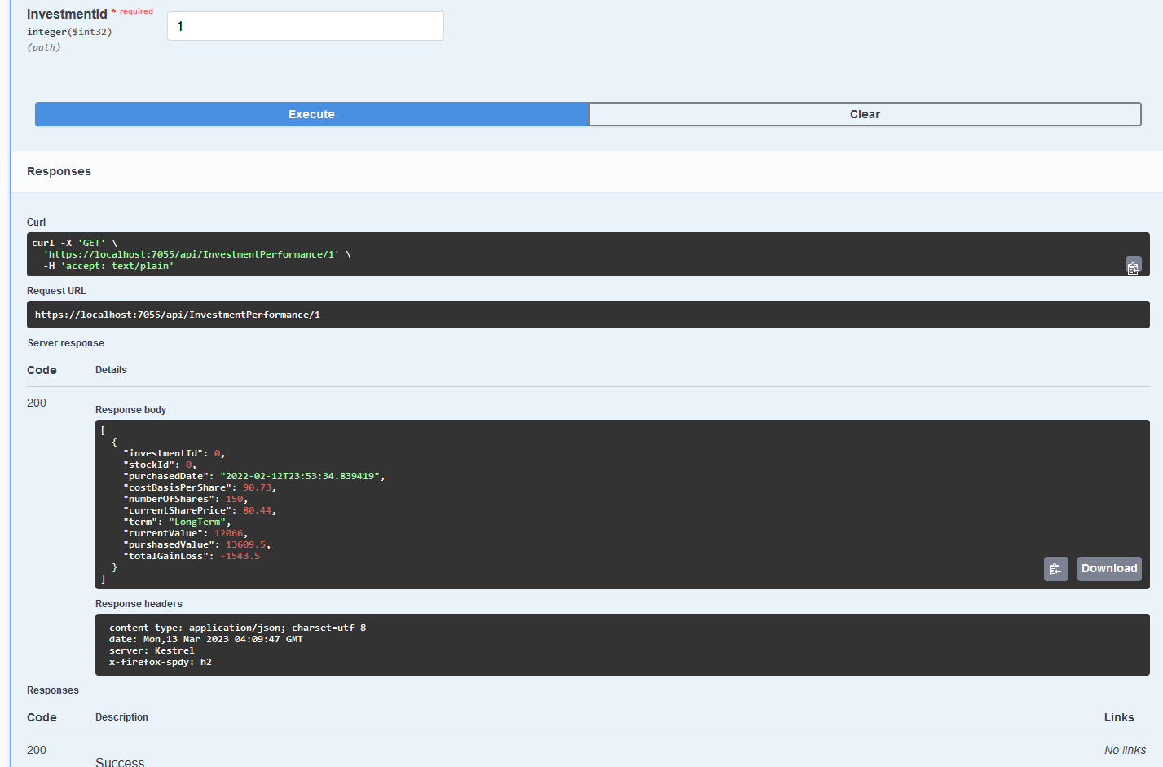  
  
  
  
If you want to add more data or change it for testing, you will need to delete the data from the database.  
  
The easiest way is delete the database, make changes to the Seed class in the persistence project and then debug again.  
  
